**System Design Document for Roadie**

Sponsor

**Electrical, Computer, Software & Systems Engineering at Embry-Riddle Aeronautical University**

Released 04 December 2014

**Are We There Yet?**

# **Revision History**

|  |  |  |
| --- | --- | --- |
| Date | Reason for Change | Version |
| 27 Nov 2014 | Initial Draft | 0.1.0 |

Table of Contents

**Revision History** ii

**1.** **Introduction** 1

**1.1** **Purpose** 1

**1.2** **Problem Statement** 1

**1.3** **Scope** 1

**1.4** **Team Information** 1

**1.5** **Overview** 1

**2.** **System Overview** 2

**2.1** **Coordination Subsystem** 3

**2.2** **Challenge Subsystem** 3

**2.3** **Movement Subsystem** 3

**3.** **Design Considerations** 5

**3.1** **Assumptions** 5

**3.1.1** **Operation** 5

**3.1.2** **Rule Changes** 5

**3.2** **Dependencies** 5

**3.2.1** **Intersystem Communication** 5

**3.2.2** **Power** 5

**3.3** **Constraints** 5

**3.3.1** **Size** 6

**3.3.2** **System Power Draw** 6

**3.3.3** **Monetary** 6

**3.3.4** **Technical Expertise** 6

**3.4** **Industrial Standards Followed** 6

**3.5** **Safety Constraints and Considerations** 6

**3.5.1** **Electrical Hazards** 6

**3.5.2** **System Heating** 7

**3.5.3** **Battery Nominal Voltage** 7

**3.6** **Environmental Considerations** 7

**3.6.1** **Component Waste** 7

**4.** **System Design** 8

**4.1** **High Level Architecture** 8

**4.2** **System State Definitions** 8

**4.3** **System State Diagram** 9

**5.** **Decomposition of Coordination Subsystem** 11

**5.1** **Subsystem Architecture** 11

**5.1.1** **Assumptions** 11

**5.1.2** **Dependencies** 12

**5.1.3** **Constraints** 12

**5.2** **Functional Diagrams** 13

**5.3** **Hardware Diagrams** 13

**5.4** **Interfaces** 13

**5.5** **Parts Budget** 13

**6.** **Decomposition of Challenge Subsystem** 13

**6.1** **Subsystem Architecture** 13

**6.1.1** **Assumptions** 13

**6.1.2** **Dependencies** 15

**6.1.3** **Constraints** 15

**6.2** **Functional Diagrams** 15

**6.3** **Hardware Diagrams** 15

**6.4** **Interfaces** 15

**6.5** **Parts Budget** 15

**7.** **Decomposition of Movement System** 16

**7.1** **Subsystem Architecture** 16

**7.1.1** **Assumptions** 16

**7.1.2** **Dependencies** 16

**7.1.3** **Constraints** 17

**7.2** **Functional Diagrams** 17

**7.3** **Hardware Diagrams** 17

**7.4** **Interfaces** 17

**7.5** **Parts Budget** 17

**8.** **System Test Plan** 18

**9.** **Appendix B** 19

**9.1** **Competition Course** 19

**10.** **References** 20

Table of Figures

**Fig. 2**: Division of Roadie into three subsystems. 2

**Fig. 3**: High level description of the systems in Roadie. 3

**Fig. 4:** High level design of the system. The system has been divided into Coordination (green), Movement (blue) and Challenge (red) subsystems. Power flowing through the system is represented with a red line, input to the system is represented by a blue line and any output from the system is represented by a black line. 8

**Fig. 1**: State diagram for Roadie 10

**Fig. 5**: Decomposition of Coordination subsystem for Roadie. 11

**Fig. 6**: Decomposition of Challenge subsystem for Roadie. 13

**Fig. 7**: Decomposition of Movement subsystem Roadie. 16

**Fig. 8** Competition course for SoutheastCon[1]. 19

# **Introduction**

## **Purpose**

## **Problem Statement**

To create an autonomous robot to compete in the 2015 IEEE SoutheastCon student hardware competition.

## **Scope**

Roadie is intended to compete in the 2015 IEEE Southeast Con student hardware competition. The system is envisioned to complete four unique challenges:

* Correctly play Simon for 15 seconds
* Draw “IEEE” on an Etch-A-Sketch
* Twist one row of a Rubik’s cube 180 degrees
* Pick up and carry one playing card across the finish line

Roadie system is intended to successfully complete the challenges outlined above within a time limit of five minutes.

Roadie is not intended to serve any other functions or fulfill any other purposes other than competing in the 2015 IEEE SoutheastCon competition.

## **Team Information**

|  |  |
| --- | --- |
| Name | Role |
| Brian Powell | Team Leader |
| Michael Philotoff | Software Manager |
| Alex Senopoulos | Developer |
| Brian Sterling | Hardware Manager |

## **Overview**

# **System Overview**

Roadie is broken down three main subsystems: (1) the Coordination subsystem, (2) the Challenge subsystem and (3) the Movement subsystem. The division of these subsystems is illustrated in **Fig. 1**.

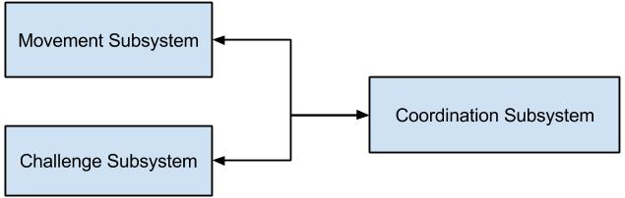

**Fig. 1**: Division of Roadie into three subsystems.

The Coordination subsystem relays information to both the Challenge subsystem and the Movement subsystem. The components of Roadie were broken into subsystems based upon what other components they interacted with and what task they set out to perform. For example, all of the interactors for challenges (Simon, Etch-A-Sketch, Rubik’s cube and playing card), were divided into the Challenge System since the interactors represent the means through which Roadie will physically manipulate the challenges. The Coordination System encompasses the microcontrollers as well as the object detectors and line sensors. The reasoning behind such decisions is that the object detectors and line sensors will send correction information that will be interpreted by the microcontroller to navigate Roadie to the right challenge as well as identify the correct challenge upon arrival. The Movement system is comprised of the motors and their associated wheels. This is due to the fact that the motors and wheels are responsible for moving the system to the intended destination.

The system architecture of Roadie is designed in a layered approach, depicted in **Fig*.* 2** below, in order to better divide the work being done and to aid in the conceptualization of the system design.

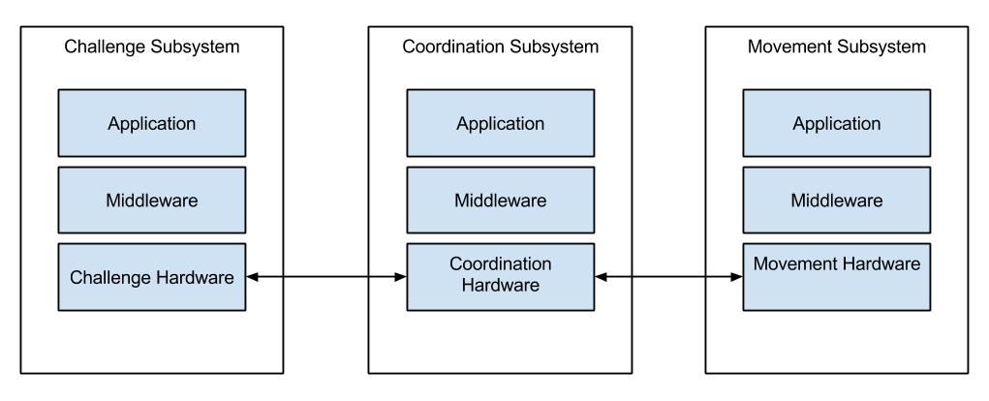

**Fig. 2**: High level description of the systems in Roadie.

The responsibilities of each system is shown in the sections below.

## **Coordination Subsystem**

The Coordination subsystem is responsible for making sure that all communications get to the correct subsystem and that all systems are operating normally. The Coordination subsystem’s applications are in the form of feedback from the sensors. This means that any information from the line sensors and the object detection sensors will have to be interpreted and handled by the subsystem. The interpretation will be handled by the Coordination subsystem’s middleware or software. The software is able to interpret the data coming in from the corresponding sensors, be it line information or object information, and send it to the correct interface on its coordination hardware. These interfaces include serial interfaces on both microcontrollers as well as pulse width modulation (PWM) outputs on both microcontrollers.

## **Challenge Subsystem**

The Challenge subsystem is responsible for interacting will all the challenges. This subsystem receives completion instructions from the Coordination subsystem and is able to interpret them correctly. The Coordination subsystem sends completion information to the Challenge subsystem over a physical interface, either serial or PWM. These interfaces then send information to the middleware of the Challenge subsystem, its software. The Challenge subsystem’s software are functions to be able to complete the Etch-A-Sketch challenge, the Rubik’s Cube challenge, the Simon challenge and the card challenge. The Challenge subsystem’s functions are able to manipulate the correct challenge interactor to complete the challenge in the appropriate manner.

## **Movement Subsystem**

The Movement subsystem is responsible for moving the chassis along the course, based on navigation instructions from the Coordination subsystem. The Movement subsystem includes the chassis, which is a vital part to making the entire system move. The Movement subsystem receives information from the Coordination subsystem over PWM signals. The Movement subsystem takes the received signals and translates them with its middleware in the form of software. The software determines the correction function call, be it moving the system left or right for example, and then executes the call on its application layer. The application layer includes the motor controllers that drive the subsystem’s motors.

# **Design Considerations**

This section outlines the assumptions, dependencies and constraints imposed upon the system as a whole. Additionally, industry standards followed, safety constraints and considerations as well as environmental considerations are enumerated in this section.

## **Assumptions**

During construction of the system, assumptions were made that affect the system as a whole. These assumptions can be found enumerated below.

### **Operation**

It is assumed that the system will only be operated for the purposes and in a manner for which it was designed for. That is to say that the system would not perform successfully were it to be used to fend off an attack from a silver back gorilla. The system has been designed with the sole purpose of competing in the 2015 IEEE SouthEastCon competition. As such, it is assumed that the system will only operate in such a venue. Furthermore, it is assumed that any operation of the vehicle will coincide with the rules and regulations outlined in [1]. Any deviations from the regulations will result in overall system failure.

### **Rule Changes**

It is assumed that rules governing the system will not change in such a manner that the system will be rendered inoperable. Should the rules change to such a degree, the system would ultimately fail as the design of the system would no longer fit the rules.

## **Dependencies**

During system design and construction, design choices were made that have underlying dependencies. Such dependencies are shown in the section below.

### **Intersystem Communication**

The system is designed in a way that all subsystems rely upon each other to effectively and correctly compete. As such, it is important that all subsystems are working properly. If the system is unable to properly communicate amongst itself, the system will not be able to successfully complete the course.

### **Power**

Since all components of the system will draw power from the same power source, all of the components depend upon the power source starting with a full charge. Furthermore, all components are dependent upon the power source operating dependently and normally. Any abnormalities in the power source could prove disastrous for the entire system.

## **Constraints**

During construction of the system, constraints were imposed upon the system which affected the overall system designed. These constrains can be found enumerated below.

### **Size**

According to the rules and regulations for the 2015 IEEE SouthEastCon competition pur forth in [1], the system must fit within a one foot by one foot by one foot cube. As such, the system design had to reflect these size constraints. This affected the design choices and implementations since the system had to ultimately fit inside the aforementioned cube.

### **System Power Draw**

Since course rounds last five minutes according to [1], design constraints were imposed upon how much power the system could draw. If the system had very large electrical components, it is probable that the system would not last the entire five minute competition duration.

### **Monetary**

Since the system did not have an unlimited budget, monetary costs were a constraint placed on the system. While it may have been desirable to build the chassis out of titanium or carbon fiber to save on weight, the budget ultimately prohibited such a design consideration. Furthermore, electrical components and accessories were of a lesser accuracy compared to some of their more expensive counterparts due to monetary constraints.

### **Technical Expertise**

The technical expertise was another contribution to the complexity and overall design of the system. While it may have been desirable to have a system that would hover to help eliminate rolling resistance, or a rocket powered system to help with the speed at which the system ran, these designs were not feasible since they fell outside the technical abilities of the design team.

## **Industrial Standards Followed**

## **Safety Constraints and Considerations**

As the system will be operating in a public venue, safety is a very large concern. It is imperative that any operation or fault in the system will not cause harm or pose a threat to any member of the audience, nor any member of team AWTY. As such, safety considerations imposed upon the system can be found in the sections that follow.

### **Electrical Hazards**

Since the system will be powered by electrical components, especially those which output a relatively high voltage, electrical shocks pose a problem if proper steps are not take to help mitigate such events. To aid in mitigation efforts, all connections originating from the power source have been properly insulated. Furthermore, all ground connections and power connections have been implemented on opposing sides of the chassis to help mitigate accidental contact. All power sources have a single point of connection, which are also insulated. The single connection point helps to ensure that not only will it prove physically impossible to plug the power source in incorrectly, it also ensures that the power source will not be active if not plugged into the system. The final precaution taken in system design is constructing the system out of a non-conductive material. As the chassis has been constructed from wood, if any connection does come loose and makes contact with the chassis, the chassis will not have an electrical charge since wood is not a conductor of electricity.

### **System Heating**

Since the system components such as the motor controllers can draw large amounts of current, there is a potential for the components to generate a large amount of heat. As such, the chassis has been designed will as much airflow as possible. The chassis is an open air design to aid in the dissipation of heat from the electrical components. Additionally, since the system will be driven by stepper motors, attention has been made to the amount of power supplied to the stepper motors, as they have the potential to heat very quickly. For this reason, voltage regulators have been installed to ensure that the voltage supplied to the system is sufficiently below the maximum allowed voltage, also assisting in preventing overheating.

### **Battery Nominal Voltage**

The power source for the system is a lithium polymer (LiPo) battery. LiPo batteries have a very volatile nature, and as such, much attention has to be made to their care and handling. It is for this reason that a battery voltage indicator has been used on the system. Should the battery fall below it’s nominal voltage of 14.4V, not only will total system power be diminished, but the cells inside the LiPo will be harmed. Continual harming of the battery’s cells can cause the battery to become more unstable, creating a safety hazard. It is for this reason that the nominal voltage of the battery will be carefully monitored.

## **Environmental Considerations**

As students aspiring to enter the field of professional engineering, it is important that the environment is taken into consideration both before and during a project’s life cycle. The environmental considerations enumerated below have been addressed during the construction of the system.

### **Component Waste**

During construction, it is inevitable that components will be broken and or destroyed. As such, it is of the utmost importance that any destroyed component is disposed of properly. This helps to ensure that no hazardous material will be released into the environment.

# **System Design**

This section outlines the flow of data through the system, as well as how different subsystems interface and interact with the entire system.

## **High Level Architecture**

Roadie has been broken down into three subsystems: Coordination, Movement and Challenge. The flow of inputs, outputs and power between these three subsystems is illustrated in **Fig. 3** below.

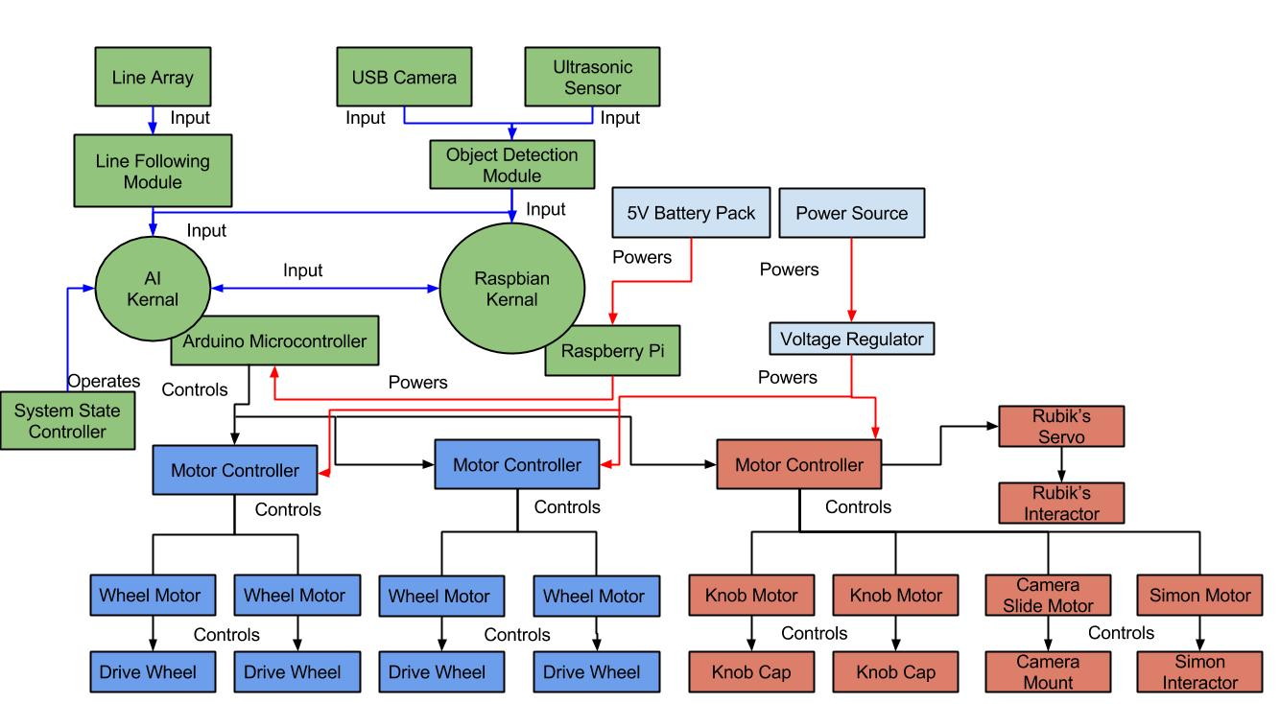

**Fig. 3:** High level design of the system. The system has been divided into Coordination (green), Movement (blue) and Challenge (red) subsystems. Power flowing through the system is represented with a red line, input to the system is represented by a blue line and any output from the system is represented by a black line.

The system has been broken down into three subsystems, each with its own core components and responsibilities. Further discussion of the subsystems as well as their location the subsystem can be found in the sections below.

### **Coordination Subsystem**

The Coordination subsystem is responsible for reading in information from the sensors on the system (ultrasonic, camera and line array), interpreting the information and distributing it to the other subsystems. This subsystem is where all of the information will flow into, and out of. That is to say that any information related to course completion will go into this subsystem, at which point the subsystem will issue initiation commands to the other subsystems. This subsystem serves as the master controller for the whole system. All logic will reside within this subsystem. The location of this subsystem on the chassis can be seen in **Bleh**.

As **bleh** shows, the major components of this subsystem are a Raspberry Pi, and Arduino Mega, a line following array, a USB camera and an ultrasonic sensor. The sensors working in tandem with the microcontrollers allow the Coordination system to know what is occurring in the environment in which the system has been placed.

### **Movement Subsystem**

The Movement subsystem is responsible for taking instructions from the Coordination subsystem, parsing them, and performing the appropriate action. For example, if the Coordination subsystem tells the Movement system that it needs to shift the chassis left to be lined up with the Etch-A-Sketch interactor, the Movement system must be able to determine how far to shift left. Additionally, if the Coordination system tells the Movement system that it has overshot the line by some percent, the Movement system must be able to turn this percentage into a quantifiable distance the chassis needs to move. This subsystem is responsible for any movement regarding the chassis. The chassis shall not move in any direction unless directed by the Coordination subsystem. The location of this subsystem on the chassis of the system can be seen in **bleh**.

As **bleh** shows, the major components of this subsystem are the chassis, the four drive motors and their associated wheels, and the motor shields for the drive motors.

### **Challenge Subsystem**

The Challenge subsystem is responsible for taking instructions from the Coordination subsystem, parsing them, and performing the appropriate action. For example, if the Coordination subsystem tells the Challenge subsystem it has arrived at the Etch-A-Sketch challenge, the Challenge subsystem must be able to determine what needs to happen to correctly interact with the Etch-A-Sketch. This philosophy is true for all challenges. Upon notification by the Coordination system, the Challenge system must correctly determine what challenge to initiate and when it has completed said challenge. All interactions with challenges will be controlled solely by the Challenge subsystem. No other subsystems will attempt to interact with the challenges. The location of this subsystem on the chassis of the system can be seen in **bleh**.

As **bleh** shows, the major components of this subsystem are the interactors for the challenges (Etch-A-Sketch, Rubik’s cube, Simon and playing card), as well as the associated motor shield.

## **System State Definitions**

In order to better define transitions and states that the system will occupy, **Table 1** has been constructed, providing both the state name, and the description of the associated state.

|  |  |
| --- | --- |
| State Name | State Description |
| Approach | The state in which the system will be once it has entered a challenge area. The approach stage will consist of the system placing itself 4.2 cm ± 0.1 cm from the challenge. |
| Challenge Abortion | The state in which the system will enter upon incorrectly interacting with a challenge. When the system enters this state, it will immediately halt execution of the current challenge, exiting the challenge area and proceeding to the line following state. |
| Challenge Completion | The state in which the system will enter upon successfully completing a challenge. This system will remain in this state until exiting the challenge area. |
| Challenge Identification | The state in which the system attempts to identify the challenge it has arrived at. The system remains in this state until a positive identification. |
| Challenge Interaction | The state in which the system will attempt to complete a challenge. The system will remain in this state for as long as it is interacting with a challenge. |
| Challenge Misidentification | The state in which the system will enter upon falsely identifying the challenge it has arrived at. Should the system enter this state, this will represent a catastrophic failure. The system will proceed to the challenge abortion state. |
| Etch-A-Sketch | The state in which the system will attempt to complete the Etch-A-Sketch challenge. |
| Failed Approach | The state in which the system will enter upon stopping close than or further than 4.2 cm ± 0.1 cm. The system will proceed back to the approach state. |
| Finish | The state in which the system will enter upon crossing the finish line. The system will cease all movement. |
| Line Abandonment | The state in which the system will enter upon failing to proceed along the guidance tape. Should the system enter this state, the system will reverse direction to the last known location of the guidance tape. |
| Line Following | The state in which Roadie is following the Scotch Blue Painter’s tape located on the competition area. |
| Playing Card | The state in which the system will attempt to complete the playing card challenge. |
| Rubik’s Cube | The state in which the system will attempt to complete the Rubik’s Cube challenge. |
| Simon | The state in which the system will attempt to complete the Simon challenge. |
| Staging | The state in which the system commences operation. This state will last from the time the system is placed inside the starting area, until the LED in the starting area is turned off. |
| Zone Identification | The state in which the system will enter upon recognizing a challenge zone or finishing line. |
| Zone Misidentification | The state in which the system will enter upon failing to recognize a challenge zone. If the system were to enter this state, that would represent a catastrophic failure, resulting in termination of the round. |

**Table 1**: States that the system will occupy with their accompanying description.

By using **Table 1**, it was possible to construct the state diagrams shown in the sections below.

## **System State Diagram**

**Fig. 4** below shows the states that the system will be in, and how the system will transition from state to state.

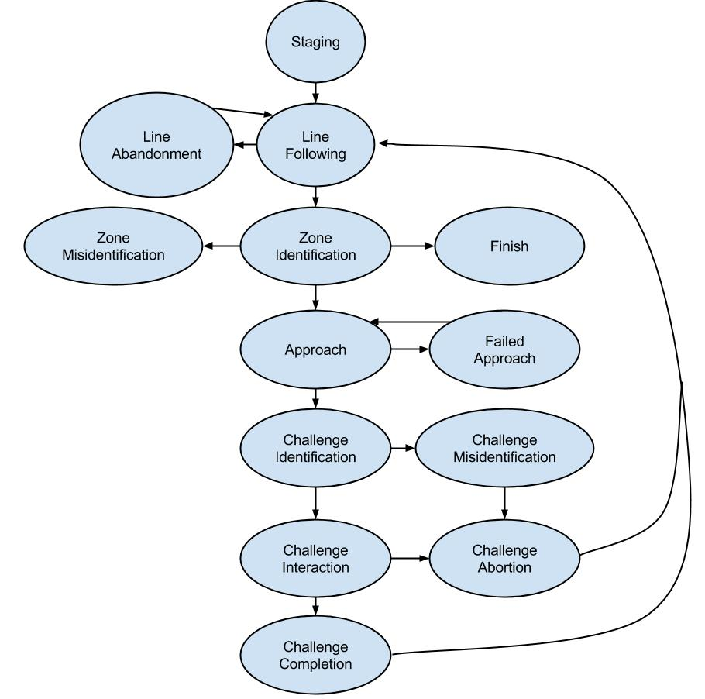

**Fig. 4**: State diagram for Roadie

# **Decomposition of Coordination Subsystem**

The architecture, requirements, use cases, sequence diagrams and requirements traceability matrix for the Coordination subsystem are included in this section.

## **Subsystem Architecture**

**Fig. 5** below, better illustrates the communications that occur amongst the subsystems in Roadie.

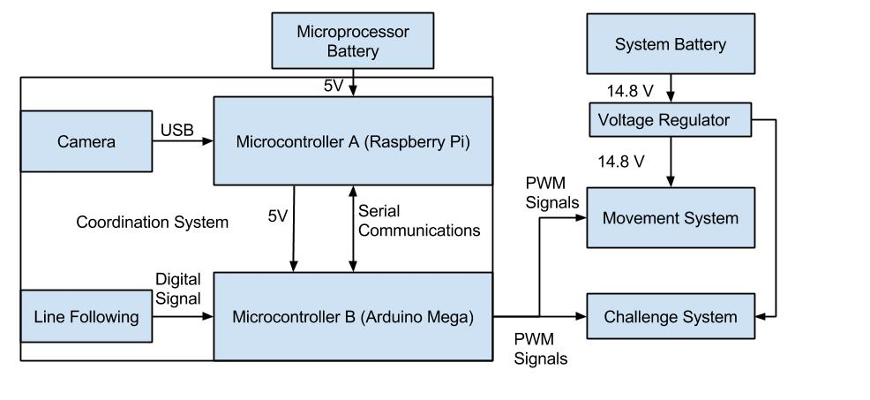

**Fig. 5**: Decomposition of Coordination subsystem for Roadie.

As depicted in **Fig. 5**, the Coordination subsystem is composed of two microcontrollers, both communicating with each other over a serial interface. The Arduino Mega is the primary micro controller, interpreting inputs from the reflectance array (line following) and issuing commands based on values received.

The coordination subsystem is responsible for the navigation and challenge identification process of Roadie. The subsystem consists of object detection, line following, and subsystem coordination.

Object detection allows Roadie to identify what object it has arrived at. By using object detection, Roadie will be able to determine what challenge needs to be completed as well as how to align with the challenge.

Line following allows Roadie to traverse the competition area. Roadie will use its line following capabilities to navigate from the starting area to the various game stations.

Subsystem coordination allows Roadie to know what each subsystem is doing at any given moment. This will aide in ensuring that Roadie will successfully complete all tasks.

### **Assumptions**

During operation, it is assumed that Roadie will begin with sufficient battery to complete the course. If the system is started with a battery that is not charged enough, the system will not be able to successfully complete the course.

It is also assumed that Roadie will be operating in the competition area shown in **Fig. 8**, and only the competition area shown in aforementioned figure. Since Roadie has been designed to compete in IEEE Southeast Con 2015, any course modifications will render the system inoperable. Furthermore, it is assumed that the course will be free of obstructions and obstacles. Any obstacles will prevent Roadie from completing the course. Assumptions have also been made regarding the course construction. It is assumed that the course will be constructed according to the methods and materials outlined in [1].

The object detection in the Coordination subsystem will only operate on the challenges outlined in [1]. Any modifications to the challenges or any different items introduced into the challenge area will create a problem for Roadie.

Assumptions have been made regarding the subsystem coordination. If one of the subsystems gives throws an unexpected error, or an error that the master controller is not prepared for, the entire system will fail.

### **Dependencies**

The Coordination subsystem depends on the Challenge subsystem and Movement system to relay information back to it so that it may guide Roadie in course completion. If this connection is broken or fails, Roadie will ultimately fail.

Problems arising from dependencies include any mechanical failure which would render the system inoperable. Furthermore, electrical issues or corrupted data will cause the system to fail the competition round.

### **Constraints**

The Coordination subsystem is constrained by the clock speed of the selected microcontroller as well as the interfaces through which the other subsystems will communicate. The system is also constrained by the rules and regulations laid forth in [1]. All code and logic in the Coordination subsystem must fit within the system memory of the microcontrollers.

## **Functional Diagrams**

## **Hardware Diagrams**

## **Interfaces**

## **Parts Budget**

# **Decomposition of Challenge Subsystem**

The architecture, requirements, use cases, sequence diagrams and requirements traceability matrix for the challenge system are included in this section.

## **Subsystem Architecture**

**Fig. 6** shows the decomposition of the Challenge subsystem into its major components.

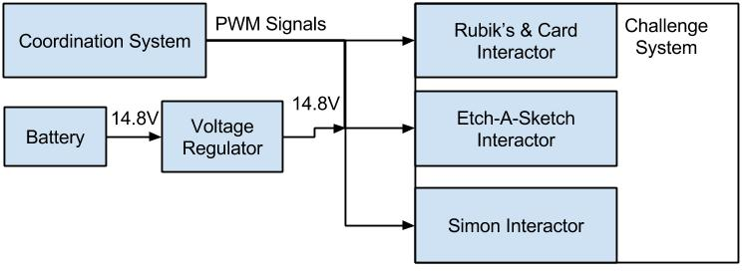

**Fig. 6**: Decomposition of Challenge subsystem for Roadie.

The challenge subsystem is responsible for completing all the challenges listed in [1]. This subsystem includes a Rubik’s & Card interactor, an Etch-A-Sketch interactor and a Simon interactor.

Interacting with the Rubik’s cube means that Roadie will attempt to turn one row of the Rubik’s cube 180 degrees. Roadie will be able to positively identify the Rubik’s cube and position itself over the Rubik’s cube. Interacting with Simon means that Roadie will play Simon for 15 seconds, correctly identifying and pressing the illuminated segments. Interacting with the Etch-A-Sketch means that Roadie will successfully draw “IEEE” on the Etch-A-Sketch. Interacting with the playing card means that Roadie will successfully pick up a playing card and carry it across the finish line.

### **Assumptions**

It is assumed that all challenges will be exactly as described in [1]. Furthermore, it is assumed that all of the challenges will perform as expected. That is to say that it is assumed that the Etch-A-Sketch knobs will perform normally. They will not have encountered unexpected wear during repeated competition rounds. Furthermore, the Rubik’s cube will be able to be rotated without an extraordinary amount of effort. If the Rubik’s cube requires more effort to be twisted than expected, Roadie will be unable to twist the cube. If the segments on Simon do not illuminate properly after multiple course rounds, Roadie will be unable to properly identify Simon.

It is assumed that Roadie will operate in the competition area shown in **Fig. 8**.

### **Dependencies**

The Challenge subsystem is wholly dependent upon the Coordination subsystem. The Coordination subsystem notifies the Challenge subsystem as to what challenge it has arrived at. From here, the Challenge subsystem will determine which interactor to activate. Without notification from the Coordination subsystem, the Challenge subsystem will be unable to perform its task. Furthermore, the Challenge subsystem relies on the challenges being exactly as described as laid forth in [1].

### **Constraints**

The Challenge subsystem is constrained by the clock speed and memory in the microcontrollers. The Challenge subsystem must be able to coincide with the code and logic from the other subsystems. Additionally, all hardware being used by the Challenge subsystem must fit on the chassis in a manner in which it will not interfere with the other systems. The Challenge subsystem must abide by all rules in regulations laid forth in [1].

## **Functional Diagrams**

## **Hardware Diagrams**

## **Interfaces**

## **Parts Budget**

# **Decomposition of Movement System**

The following section describes the architecture, requirements, use cases, sequence diagrams, and requirements traceability of the Movement subsystem.

## **Subsystem Architecture**

**Fig. 7** shows the decomposition of Roadie’s Movement subsystem into major components.

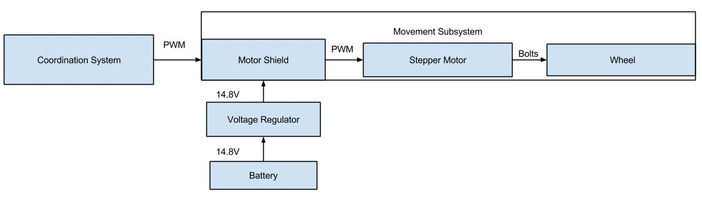

**Fig. 7**: Decomposition of Movement subsystem Roadie.

The Movement subsystem for Roadie consists of the drive motors, wheels and the chassis. This subsystem is responsible for interpreting the movement commands sent to it from the Coordination subsystem. In turn, the Movement subsystem will advance the chassis to the specified location.

### **Assumptions**

It is assumed that the competition area will be as shown in **Fig. 8**. The Movement subsystem has been calibrated to respond to the surfaces laid out in the aforementioned figure. If the surface is different from what is described, there is no guarantee that Roadie will be able to correctly move. It is also assumed that the Movement subsystem will be able to interpret all of the commands originating from the Coordination subsystem. If the Movement subsystem is unable to do so, Roadie will not move as expected.

### **Dependencies**

The Movement subsystem is purely dependent upon the Coordination subsystem for the direction and distance to move Roadie. The Movement subsystem also depends on the environment it is placed in being free of obstacles or other movement inhibitors. Furthermore, the environment which Roadie is placed in must be the same as the competition area as shown in **Fig. 8**. Roadie has been constructed to work with this course format and no other.

One problem arising from dependency is that the system will fail to move. If the Movement subsystem is unable to get information from the Coordination subsystem, Roadie will be unable to move, representing a total system failure.

### **Constraints**

All of the code and logic for the Movement subsystem must fit within the space allotted on the microcontroller. Furthermore, the speed at which the code can run is constrained by the clock speed on the microcontroller. The Movement subsystem may only move as fast as the motors that have been selected to drive Roadie. All components in the Movement subsystem must comply with all rules and regulations set forth in [1].

## **Functional Diagrams**

## **Hardware Diagrams**

## **Interfaces**

## **Parts Budget**

# **System Test Plan**

# **Appendix B**

This appendix includes a diagram of the competition course as well as pictures of the individual challenges the system must complete. Also included is a picture of the tape that will designate the line the system must follow.

## **Competition Course**

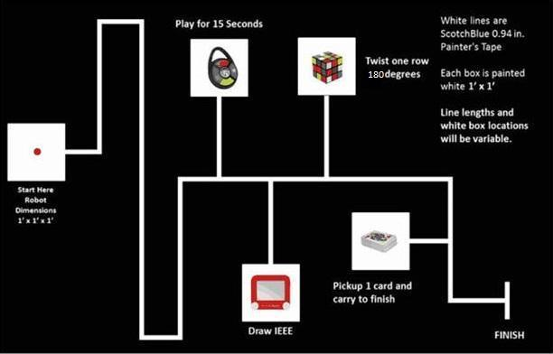The course, as shown in **Fig. 8** below, shows the rough outline of the track the system will follow, as well as what a challenge station would look like.

**Fig. 8** Competition course for SoutheastCon[1].

# **References**

[1] IEEE Nova Southeastern University. (2014, September 7). IEEE SoutheastCon 2015 Student Program - Hardware Competition. Retrieved September 7, 2014, from IEEE SoutheastCon 2015: http://www.ewh.ieee.org/reg/3/southeastcon2015/StudentProgram.html